Henkel
Functional Design Specification
SampleManager PhaseB

Document Reference | xxxx-FDS-SAMPLEMANAGER-B001
Version | 1.0
Last updated by | Zhenjuan.Zhang
Template Version | 1.0-0
Date
Status | Draft

chuxiaDocument Signoff
Name | Position | Company | Signature | Date

Table of Contents
Contents
1 Table of Contents 3
2 Introduction 5
2.1 This Document 5
2.1.1 Document overview 5
2.1.2 Disclaimer 5
2.1.3 Purpose 5
2.1.4 Scope 5
2.2 Synopsis 5
2.3 Definitions 5
2.4 References 6
3 Project Brief 7
3.1 Project Overview 7
3.1.1 Project detail 7
3.2 Functional Requirements 7
3.2.1 Sample Management 7

Version Management
Version | Description | Name | Date
1.0 | Created | Zhenjuan.Zhang

Introduction

This Document

Document overview
This document describes the system functionality of Phase B pilot stage covered in the Henkel QCLad System RTM User Requirements Analysis Report.

Disclaimer
The screenshots used below are screenshots generated during the system standard functions or system configuration, as well as customer sample screenshots, the final design may be different from the screenshots in the document, and the data on the screenshots is not the real data of the system, only for reference.

Purpose
This document is used to provide a detailed description of the functionality of the SampleManager system, identifying a description of the system functionality that meets the user's business needs as specified in the phase B pilot stage of User Requirements Analysis Report. The functionality of phase A, which is already deployed in the system, will not be described further

Scope
- Document the functional specifications of the laboratory management system based on the requirements described in the User Requirements Analysis Report.
- Determine the implementation of functionality in the system based on the needs described in the user needs analysis report

Synopsis
The core application functionality of the QCLad system is the laboratory sample process management functionality, including sample management, SAP interface, task scheduling, master data, reporting, architecture and security.;

Definitions
The following abbreviations and definitions are assumed throughout this document.
Term/  Abbreviation | Meaning | Description
FS | Function Specification | This Document
RMB | Right Mouse Button | Using RMB various Sample Manager options can be displayed
QCLAD | SampleManager | Software Name

References
The following references are made in this document.
Ref. No. | Reference | Description

Project Brief

Project Overview

Project detail
Implementation of SampleManager QCLad will streamline Sample Management, Reports, Dashboards, Instrument and Equipment management, Instrument interfacing and External application integration together with the associated data acquisition across Henkel’s labs.

Functional Requirements

Sample Management

Lab Testing Process Workflow

Business Scenarios
Generally, samples and tests will flow the process of workflow which is deployed during project stage phase A. In this document it will be referred to as the lab testing process and will be used in the lab as a base process for other subsequent workflows.

RTM Mapping

URS Ref. | Requirement | Type
4.1.5.1.1 | System shall be able to manage Standard RM test for Incoming workflow. （Standard RM） | Configuration
4.1.5.1.2 | System shall be able to manage Standard in process testing for semi finished and finished goods workflow. （without MES) | Configuration
4.1.5.1.3 | System shall be able to manage Standard finished goods outgoing test workflow. | Configuration
4.1.5.1.10 | System shall be able to manage Test for SCMS/NCMR /CCMS investigation workflow. | Configuration

Function Design
The lab testing process workflow defines the lifecycle of a sample from received status to authorization. See the flow chart below.
Samples and tests will be run according to this workflow if not otherwise specified.
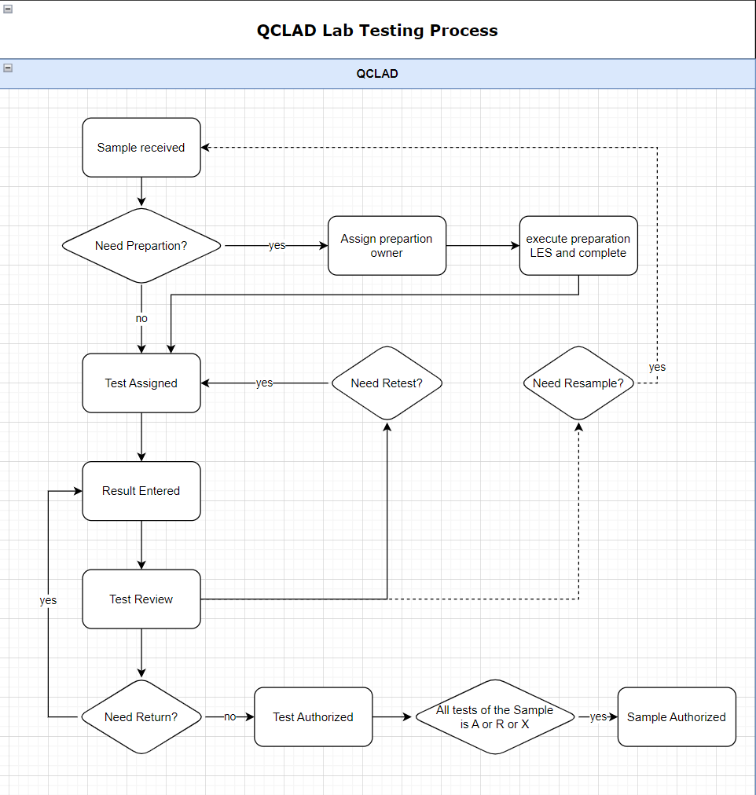

Truck Workflow

Business Scenarios
There are TRUCK samples that need to be created manually first, and then the sap inspection batch will be pushed. QCLAD needs to be able to return the results correctly.

RTM Mapping
URS Ref. | Requirement | Type
4.1.1.1.1 | System shall be able to login samples using configurable templates | Configuration
4.1.1.1.3 | System shall be able to create samples manually for standard testing. | Configuration

Function Design

Design Overviews
Users can create Tank samples and tests manually. QCLAD shall retrieve the results to SAP after inspection lot is received. (Based on RTM as above).
In the Sample management cabinet, samples and tests will be displayed in subfolders categorized by sample type. Truck sample will be grouped in sub folder IQC-TRUCK.

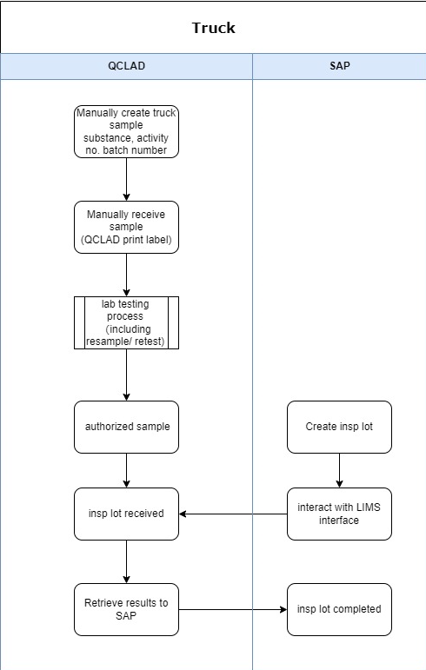

Process Design
Sample Login:
Truck Samples will be login by manually running sample login workflow Truck Sample by navigating to: Public folders-Sample Management-Create Sample.
The user needs to select the MLP and enter the batch number. QCLAD system will automatically fetch the IDH and activity number from the master data.
For truck material, creates the sample id by adding the entries.

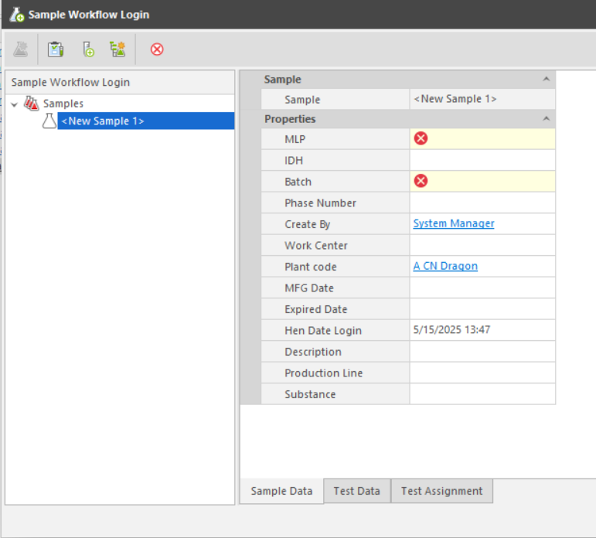
Properties in entity template clarification in LIMS:
No. | Properties | Type | Prompt Type | Description
1 | MLP | Identity | Mandatory | Links to MLP table
2 | Batch | Text | Mandatory | Batch id
3 | Plant code | Text | Optional | Links to Plant table
4 | Activity No | Numeric | Optional | Fetch from MLP
5 | Work Center | Text | Optional | Links to Work centre table
6 | Date Login | Date | Optional | Current date, modifiable.
7 | Create By | Operator | Optional | Current operator
8 | Description | Text | Optional | Descriptiom
9 | Substance | Identity | Optional | Fetch from MLP
10 | MFG Date | Date | Optional | Manufacture date
11 | Expired Date | Date | Optional | Expiration date
14 | Production Line | Identity | Optional | Fetch from MLP
Sample Receiving:
The user needs to find the specified sample from the New Sample Pending Receiving folder and right-click Receive Samples button to open the Sample Receiving window. After the sample is received, the sample label is automatically printed to the label printer in the corresponding work centre.
Sample Authorize:
When all tests for a sample are in the authorized or rejected status, the sample will automatically become authorized.
Authorized JIT samples will be listed in the Sample management-Authorized samples folder. System will highlight the JIT samples which has not received inspection lots from SAP by highlighting the background color in the Authorized samples folder.

Truck Samples are not automatically marked as waiting to be sent results to SAP when the sample is authorized, but need to wait for a response from the sap interface.

SAP interactive
Truck sample is created manually in QCLAD system.
When inspection lot created in SAP is pushed to QCLAD, interface would find the sample already existed in system and save the inspection lot number in the field ‘hen_inspection_lot’ and mark the field ‘hen_to_be_sent’ to true.

JIT Workflow

Business Scenarios
There are JIT samples that need to be created manually first. When all tests are all completed and reviewed, QCLAD will send the message which including sample decision information(A/R) to the MES. Then SAP will push the inspection lot and QCLAD needs to be able to return the results correctly.

RTM Mapping
URS Ref. | Requirement | Type
4.1.1.1.1 | System shall be able to login samples using configurable templates | Configuration
4.1.1.1.3 | System shall be able to create samples manually for standard testing. | Configuration

Function Design

Design Overviews
Users can create JIT samples and tests manually. QCLAD shall send the message to MES when sample is authorized and retrieve the results to SAP after inspection lot is received. (Based on RTM as above).
In the Sample management cabinet, samples and tests will be displayed in subfolders categorized by sample type. Truck sample will be grouped in sub folder IQC-JIT.

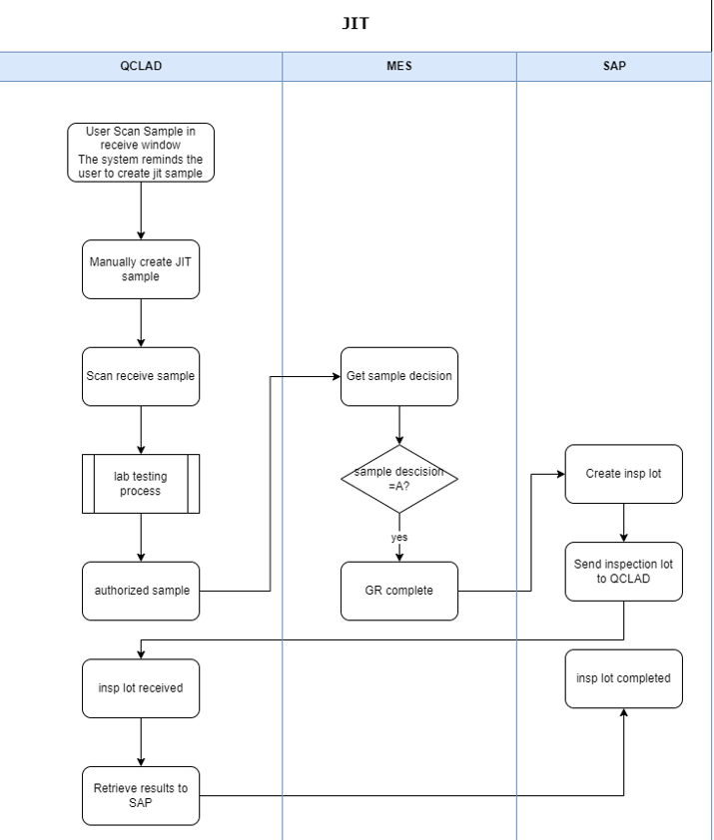

Process Design
Sample Login:
JIT Samples will be login by manually running sample login workflow JIT Sample by navigating to: Public folders-Sample Management-Create Sample
System shall remind user to create JIT sample when scanning receive the sample which has not yet been created in QCLAD
The user needs to select the MLP and enter the batch number. QCLAD system will automatically fetch the IDH and activity number from the master data.


Properties in entity template clarification in LIMS:
No. | Properties | Type | Prompt Type | Description
1 | MLP | Identity | Mandatory | Links to MLP table
2 | Batch | Text | Mandatory | Batch id
3 | Plant code | Text | Optional | Links to Plant table
4 | Activity No | Numeric | Mandatory | Activity number
5 | Work Center | Text | Optional | Links to Work centre table
6 | Date Login | Date | Optional | Current date, modifiable.
7 | Create By | Operator | Optional | Current operator
8 | Description | Text | Optional | Descriptiom
9 | Substance | Identity | Optional | Fetch from MLP
10 | MFG Date | Date | Optional | Manufacture date
11 | Expired Date | Date | Optional | Expiration date
14 | Production Line | Identity | Optional | Fetch from MLP
Sample Receiving:
Users can receive sample by scanning the MES label in sample receive window or manually finding the specified sample from the New Sample Pending Receiving folder.
After the sample is received successfully, the sample label is automatically printed to the label printer in the corresponding work centre.
The MES label should have a QR code that contains the information in the same format as phase A.
When a user scans to receive a JIT sample but the sample has not yet been created in QCLAD, system will remind the user in the scan window that the sample is a JIT sample.
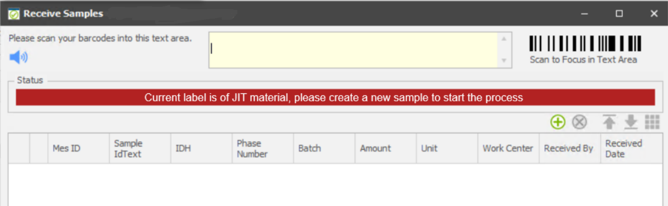
Sample Authorize:
When all tests for a sample are in the authorized or rejected status, the sample will automatically become authorized.
Authorized JIT samples will be listed in the Sample management-Authorized samples folder. System will highlight the JIT samples which has not received inspection lots from SAP by highlighting the background color in the Authorized samples folder.
JIT Samples are not automatically marked as waiting to be sent results to SAP when the sample is authorized but need to wait for a response from the sap interface.

SAP interactive
JIT sample is created manually in QCLAD system.
When inspection lot created in SAP is pushed to QCLAD, interface would find the sample already existed in system and mark it as waiting to be sent results.

MES interactive
When the sample is authorized, QCLAD determines the sample decision based on the on spec field on the sample table and sends a string to the MES interface.

MES Interface

General requirement
Refer to section 3.2.6.1 of the Phrase A FS document SampleManager - Functional Design Specification-v6.docx

RTM Mapping
NA

MES requests the results of the JIT process from QCLAD

Introduction
In the JIT process, there will initially be no inspection lot in SAP. Samples need to be manually received, results recorded and stored in QCLad. This process requires manual handling to ensure that sample receipt and result recording are completed. After the JIT sample audit is completed, QCLAD will send the quality results back to MES, and MES will provide a result feedback interface.
When the SAP system generates an inspection batch, it is sent to QCLAD. At this point, the QCLAD system will use (factory + batch + IDH + activity number + lot) to match the sample.
.

Interface URL address
MES should provide the URL
Request whether the MES interface requires Token, if so please provide the Token interface address and parameters.

Field Mapping

No. | MES Field |  | Mapping QCLAD field
 | Field | Description | Table | Field
1 | Sample Label Number | Unique ID for the sample | sample | HenMesId
2 | Batch Number | SAP Batch Number | sample | BatchName
3 | Material Number | SAP Material Code | Substance | Identity
4 | Material Description | Description of material | Substance | Name
5 | Plant Code | SAP Plant | sample | HenPlant
6 | Sample approval/rejected Time | Date and time sample was approved/rejected | sample | DateAuthorised
7 | Operator Name | Operator who approved sample | sample | Authoriser
8 | Sample Status | "Pass", "Reject" | sample | OnSpec

Exampled transaction json
{
"MesSampleId": "0000574979",
"batch": "B230501A",
"MaterialNumber": " 1165394 ",
"MaterialDescription": " LOCTITE LIOFOL LA 4501 25KG ",
"plant": "0759",
"AuthorisedDatw": "2025-06-08 13:09",
"OperatorName ": "zzj",
"SampleStatus ": "Pass",
}

Exampled response json
{
" MesSampleId": "0000574979",
"Status" :0
"Message":””
}
And
{
"MesSampleId": "0000574979",
"Status" :1
"Message":” sample number does not exist”
}

Frequency
As frequency defined in the scheduled background task in QCLAD.

System Logic
BackgroundTask or workflowTask: SendJITResultToMESTask.
When JIT sample is authorized , QCLAD will set the filed MES_to_be_sent to true and wait for sending the sample decision to MES.
- The new background task SendResultToMESTask executes every 5 minutes.
- Retrieve all the JIT samples (or only the current sample) that with MES_to_be_sent is true and MES_Has_sent is false.
- Loops the selected samples. For each sample, if the sample calls the MES interface, the sample information and test results are sent back to MES. If the test results are qualified (i.e., the Onspec field in the sample table is YES), the Sample Status is marked as ‘Pass’; otherwise, it is marked as ‘Reject’.
- After sending the decision to MES, then set the filed MES_Has_sent to true.
- Commit the changes for the current sample.

QCLAD to MES Sample Conclusion and Adjustment IPQC

Introduction
First, we determine whether integration with MES is needed based on workcenter configuration. If integration is required, for completed/authorized IPQC samples, QCLad provides a background task to send the test results to MES. This is divided into two scenarios:
- If the sample (M1) passes the test, send plant + batch + IDH + activity number + A.
- If the sample (M1) fails the test (results exceed MLP limit), the user can choose to adjust the material (M1a, M1b, ...) and input the adjustment amount in LES. The interface will send plant + batch + IDH + activity number + R + adjusted material and adjustment amount to MES, then MES will resubmit the sample for testing (with the same activity number).

Interface URL address
MES should provide the URL
Request whether the MES interface requires Token, if so please provide the Token interface address and parameters.
接口调用方式，

Field Mapping
No. | MES Field |  | Mapping QCLAD field
 | Field | Description | Table | Field
1 | Sample Label Number | Unique ID for the sample | sample | HenMesId
2 | Process Order | SAP Process Order | sample | HenProcessOrder
3 | Batch Number | SAP Batch Number | sample | BatchName
4 | Material Number | SAP Material Code | Substance | Identity
5 | Material Description | Description of material | Substance | Name
6 | Plant Code | SAP Plant | sample | HenPlant
7 | Activity Number | SAP phase in the routing | sample | HenPhraseNumber
8 | Sample approval/rejected Time | Date and time sample was approved/rejected | sample | DateAuthorised
9 | Operator Name | Operator who approved sample | sample | Authoriser
10 | Sample Status | "Pass", "Reject", "Adjustment", | sample | OnSpec
11 | Adjust Material | Material used for any adjustment during sampling
12 | Quantity | Amount of material sampled or adjusted
13 | Resample Required | If the phase required re sample

Exampled transaction json
{
"MesSampleId": "0000574979",
"ProcessOrder ": "B230501A",
"batch": "B230501A",
"MaterialNumber": " 1165394 ",
"MaterialDescription": " LOCTITE LIOFOL LA 4501 25KG ",
"plant": "0759",
"ActivityNumber ": "0010",
"AuthorisedDatw": "2025-06-08 13:09",
"OperatorName ": "zzj",
"SampleStatus ": "Pass",
"adjustment material": "DINP,YD128",
"adjustment quantity": "2,1",
"adjustment unit": "KG,KG"

}

or

{
"MesSampleId": "0000574979",
"ProcessOrder ": "B230501A",
"batch": "B230501A",
"MaterialNumber": " 1165394 ",
"MaterialDescription": " LOCTITE LIOFOL LA 4501 25KG ",
"plant": "0759",
"ActivityNumber ": "0010",
"AuthorisedDatw": "2025-06-08 13:09",
"OperatorName ": "zzj",
"SampleStatus ": "Pass",
"adjustment": [{
"material": "DINP",
"quantity": "2",
"unit": "KG"
},
{
"material": "YD128",
"quantity": "1",
"unit": "KG"
},
{
"material": "YD128",
"quantity": "1",
"unit": "KG"
}

]
}
Or
{
"MesSampleId": "0000574979",
"ProcessOrder ": "B230501A",
"batch": "B230501A",
"MaterialNumber": " 1165394 ",
"MaterialDescription": " LOCTITE LIOFOL LA 4501 25KG ",
"plant": "0759",
"ActivityNumber ": "0010",
"AuthorisedDatw": "2025-06-08 13:09",
"OperatorName ": "zzj",
"SampleStatus ": "Pass",
"adjustment": {
"material": "DINP,YD128",
"quantity": "2,1",
"unit": "KG,KG"
}
]
}

Exampled response json
{
" MesSampleId": "0000574979",
"Status" :0
"Message":””
}
And
{
"MesSampleId": "0000574979",
"Status" :1
"Message":” sample number does not exist”
}

Frequency
As frequency defined in the scheduled background task in QCLAD.

System Logic
BackgroundTask or workflowTask: SendResultToMESTask
When IPQC sample is authorized and whose work center requires MES connection, QCLAD will set the filed MES_to_be_sent to true and wait for sending the sample decision to MES.
- The new background task SendResultToMESTask executes every 5 minutes.
- Retrieve all the IPQC samples (or only the current sample) that with MES_to_be_sent is true and MES_Has_sent is false.
- Loops the selected samples. For each sample, If the sample result is passed, then QCLAD will send it with decision "A" and do not need the adjustment information.
{
"plant": "0759",
"material": " 000000000000026911",
"batch": "B230501A",
"activityNumber": 20,
"decision": "A",
"adjustment": null
}

If the sample result is not passed, then QCLAD will send the send it with decision "R" and the adjustment information.
{
"plant": "0759",
"material": " 000000000000026911",
"batch": "B230501A",
"activityNumber": 20,
"decision": "R",
"adjustment": [{
"material": "DINP",
"quantity": "2",
"unit": "KG"
},
{
"material": "YD128",
"quantity": "1",
"unit": "KG"
}
]
}

- After sending the decision to MES, then set the filed MES_Has_sent to true.
- Commit the changes for the current sample.

QCLAD requests the production line of the Material from MES

Introduction
For increment semi-finished and finished substances in QCLad, the production line information needs to be synchronized with the data in MES. QCLad will send "plant code + material code + valuation class" to the MES interface, and the MES interface will return the production line information.

Interface URL address
MES should provide the URL

Field Mapping
TBD

Exampled transaction json
{
"material": " 000000000000026911"
……
}

Exampled response json
MES should provide the response example

Frequency
As frequency defined in the scheduled background task in QCLAD.

System Logic
BackgroundTask: SubstanceSyncTask
The background task is running daily for processing the synchronization of the substance data from MES.
- Retrieves all the increment semi-finished and finished substances for today (也就是Hen_ prodline_sync_MES为FALSE的Substances) and loop the substances.
- For each substance it will send the request to MES.
- Update the product line filed for the current substance according to the response.并将Hen_ prodline_sync_MES更改为True
- SAP的物料接口，当SAP下发物料到QCLAD时，将该Substance的Hen_ prodline_sync_MES更改为FALSE。

